**CUSTOMER CARE REGISTRY**

**Top 3 ideas - Problem statements**

### 1.When the Response Times Are Long

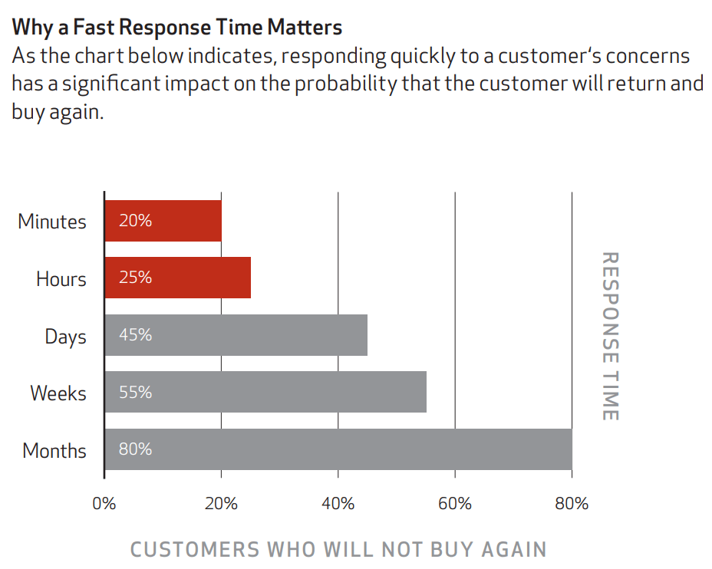

[**Source**](https://www.maritzcx.com/wp-content/uploads/2015/06/voc_ebook.pdf)

**en the world moves at break-neck speed, why should the customer be kept on hold\”0 waiting for the agent to respond?**

#### Problem:

**Customers today expect communication with service departments to be instant. In fact, they want immediate resolution of their concerns too. This is, indisputably, the first in the long list of the common problem with customer service that needs to be addressed by businesses.**

#### Reasons:

**Check out the reasons why this major problem occurs frequently:**

* **If the company does not establish a standard set of processes and practices to the field, answer and evaluate responses**
* **If there is no accountability on the part of the agent if response times have been really prolonged**
* **If agents end up doing a lot of manual work in the absence of adequate automation**
* **If agents are not trained to handle multiple queries simultaneously**

#### Solution:

**To drive yourself back into the fast lane, you need to do the following:**

* **Create a process that outlines the workflow of what an agent should do when he or she receives a customer query with the focus of handling it promptly and efficiently**
* **Ensure that your agents are aware of their roles and responsibilities along with who they are accountable to if and when there are lapses in service**
* **Make use of technology and automation that helps take care of some of the repetitive tasks through a combination of canned responses that are framed to expedite the workflow**
* **Allow your customers to reach you via multiple channels including email, website chat, phone, social, text message and allocate resources accordingly**
* **Start** [**creating a knowledge base**](https://www.proprofskb.com/blog/how-to-create-a-knowledge-base/) **to pre-package responses to the most commonly asked questions which also ensures that your service team remains consistent with their levels of service**

**Customer service issues, if left unattended, can be a frustrating experience for your client. Be proactive and keep your customers informed of how you aim to address their issues quickly.**

## 2. When Customer Reps Do Not Listen Carefully to What the Client Needs

**Your customer service problem-solving starts by diving due importance to listening. This is often overlooked, which may result in catching the customer service agent off guard with questions to which you may not have the appropriate answer.**

#### Problem:

**You may not want to be in a position where you have to listen to customers complaining. Unless you give your full attention to what the customer is saying, it will be difficult to understand what they need or how to service their problem.**

#### Reasons:

**You can land up in this situation due to the following reasons:**

* **If the customer finds it difficult to explain the issue due to a lack of knowledge of relevant technical terms**
* **If the customer has been disappointed with the product or service as it did not meet their expectations**
* **If you simply do not know the answer to the concern because you did not pay attention to what the customer said**

#### Solution:

**To help you deliver the right resolution, you can do the following:**

* **Ensure that you have understood the issue about what the customer requires and double-check the problem if required**
* **Follow it up with a genuine apology because many customers are simply looking for an acknowledgment of the mistake made by the business**
* **If you do not have a solution right away, then admit it to the customer right away**
* **On the other hand, if a ready solution is available, then share it with the customer immediately**

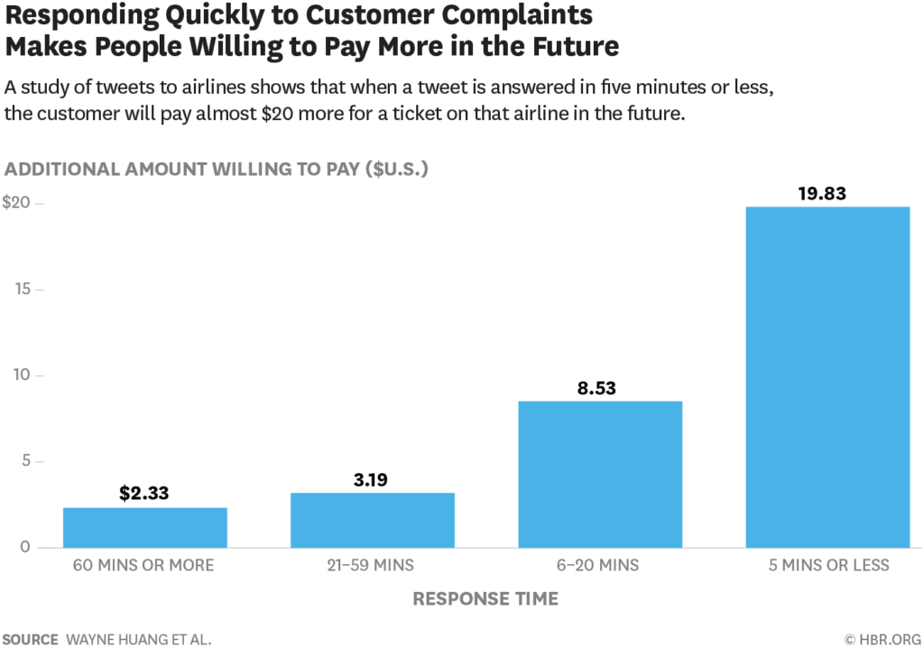

***A*** [***study published in the Harvard Business Review***](https://hbr.org/2018/01/how-customer-service-can-turn-angry-customers-into-loyal-ones) ***reported that a complaining customer handled proactively in less than 5 minutes will go on to spend more on purchases in the future.***

### 3. When the Customer Gets Transferred from One Department to Another

**When people engage with businesses, and it does not turn out as per their expectations, it is the ultimate death knell to your reputation.**

#### Problem:

**When a customer keeps getting transferred from one agent or department to another, it ensures that a customer will never return to you or your business in the future. Neither will they recommend you to people they know. This brings us to the second most common customer service problem.**

#### Reasons:

**Here are some reasons why a customer call may get transferred:**

* **If the customer agent does not have a ready solution to the query that has been put forward by the client**
* **If the rep is not the appropriate individual to offer a resolution to the issue**
* **If the agent feels that a superior will be able to offer a better solution to the problem**

#### Solution:

**To ensure that the customer is not enraged, this is what you can do to pacify the situation before transferring the customer:**

* **Inform the customer the reason, why you need to transfer the call to another agent, senior manager or department**
* **Explain the present situation in detail so that the customer understands that sticking with you may take more time to resolve the issue**
* **Request permission to transfer the call and ask if the customer has any further questions that need answering**
* **Wait for a confirmation in the affirmative and then initiate the transfer**

**Remember that the customer may already be on the brink of losing it if the call has already been transferred several times. Try not to push him any further than you need to. You do want the experience to end on a positive tone.**